DLD LAB 9

Task 1
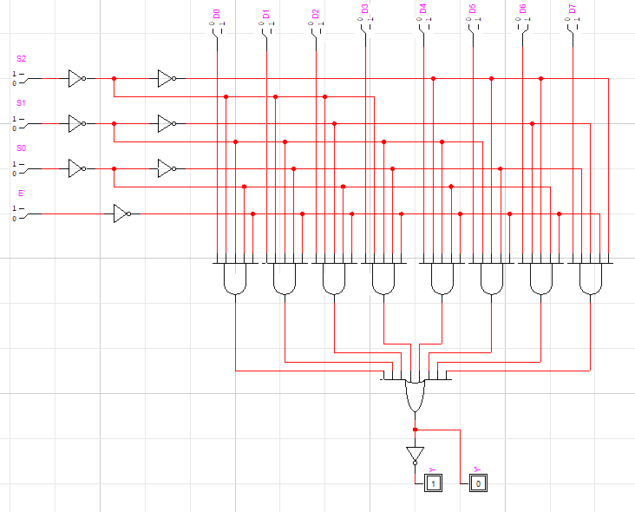
E’ | S2 | S2 | S0 | L0 | L1 | L2 | L3 | L4 | L5 | L6 | L7 | Z’ | Z
H | X | X | X | X | X | X | X | X | X | X | X | X | X
L | L | L | L | L | X | X | X | X | X | X | X | H | L
L | L | L | L | H | X | X | X | X | X | X | X | L | H
L | L | L | H | X | L | X | X | X | X | X | X | H | L
L | L | L | H | X | H | X | X | X | X | X | X | L | H
L | L | H | L | X | X | L | X | X | X | X | X | H | L
L | L | H | L | X | X | H | X | X | X | X | X | L | H
L | L | H | H | X | X | X | L | X | X | X | X | H | L
L | L | H | H | X | X | X | H | X | X | X | X | L | H
L | H | L | L | X | X | X | X | L | X | X | X | H | L
L | H | L | L | X | X | X | X | H | X | X | X | L | H
L | H | L | H | X | X | X | X | X | L | X | X | H | L
L | H | L | H | X | X | X | X | X | H | X | X | L | H
L | H | H | L | X | X | X | X | X | X | L | X | H | L
L | H | H | L | X | X | X | X | X | X | H | X | L | H
L | H | H | H | X | X | X | X | X | X | X | L | H | L
L | H | H | H | X | X | X | X | X | X | X | H | L | H

Task 2 Part 1
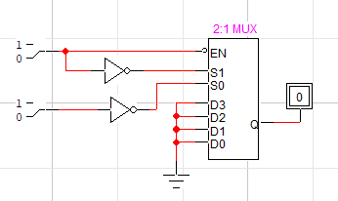
Task 2 Part 2
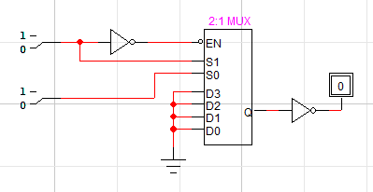
Task 2 Part 3
